# 

|  |  |  |  |  |
| --- | --- | --- | --- | --- |
| Service Out Sourcing Website |  | **Business Plan**  Software Engineering |  | Team: Team Kernel  https://team-kernel-express.myshopify.com/ |

Out Sourcing Website

Innovative Application Competition for the Service Outsourcing.

Contents

1.  0
2. Introduction 2

Project Summary 2

Team Introduction 2

Process of Task Management 6

1. Website Overview 15

Services that can get to customers using this website 15

Services that can get to Suppliers using this website 19

The cost model and feasibility analysis 19

1. Conclusion 20

Conclusion 21

Learning outcomes 21

# Introduction

## Project Summary

This is the Project for Team Kernel which is for innovative application competition for the service outsourcing of college students in Zhejiang Normal University in March 2018. So, we did this project after forming a group with 5 members in total.

Our website address is <https://team-kernel-express.myshopify.com/>

Since this website is not published user can see the website after entering the password. Password is “kernel”

**Outsourcing:** In business, outsourcing is an agreement in which one company contracts-out a part of existing internal activity to another company. It involves the contracting out of a business process, operational and non-core functions. The concept outsourcing came from the American Glossary outside resourcing and it dates back to at least 1981.Outsourcing sometimes, though not always, involves transferring employees and assets from one firm to another. Outsourcing is also the practice of handing over control of public services to private enterprise.

**Team Members:**

In total we are five members in our team. We use GitHub to work together and it makes our work easier and much better. We divided the whole work among our team members that make this task efficient as well as effective.

Our team consists of –  
**1. Irufaan Ali 201532120135 (Project manager)**

As the project manager, his job was to plan, budget, oversee and document all aspects of this project. His typical responsibilities includes: Planning, Executing, and Closing Projects — defining the project, building its comprehensive work plan, and managing to the budget.

**2.** **Rutagengwa Nicole 201532120131** **(Customer relationship manager)**

As a Customer Relationship Manager, her primary responsibility was maintaining long-term, post-sales relationships with existing customers across a wide selection of companies and industries. She played the role of the customer's advocate to ensure they are receiving appropriate support from all areas of the business.

**3. Md Mehedi Hasan 201532120142 (Technical manager)**

Typically, technical manager lead technological development activities. He leads the team developing the code. Broadly, he fills both managerial and technical expert roles.

**4. Awuku Emmanuel Kwaku 201532120137 (Developer)**

**5. Kakulekelo ilukena 202532120143 (Developer)**

Both of them played a key role in the design, installation, testing and maintenance of software systems. The programs they create are likely to help businesses be more efficient and provide a better service.

We really enjoy our work together. The work build up a very good understanding among us and it improves our team management skill.

Our GitHub Repository is <https://github.com/irufaan/team-kernel-competition>

Here are some images of our work in GitHub:

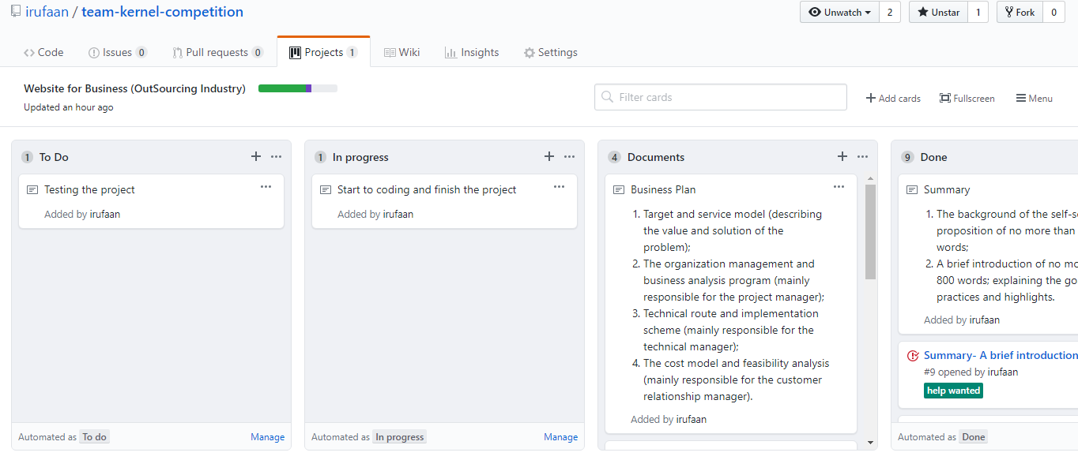

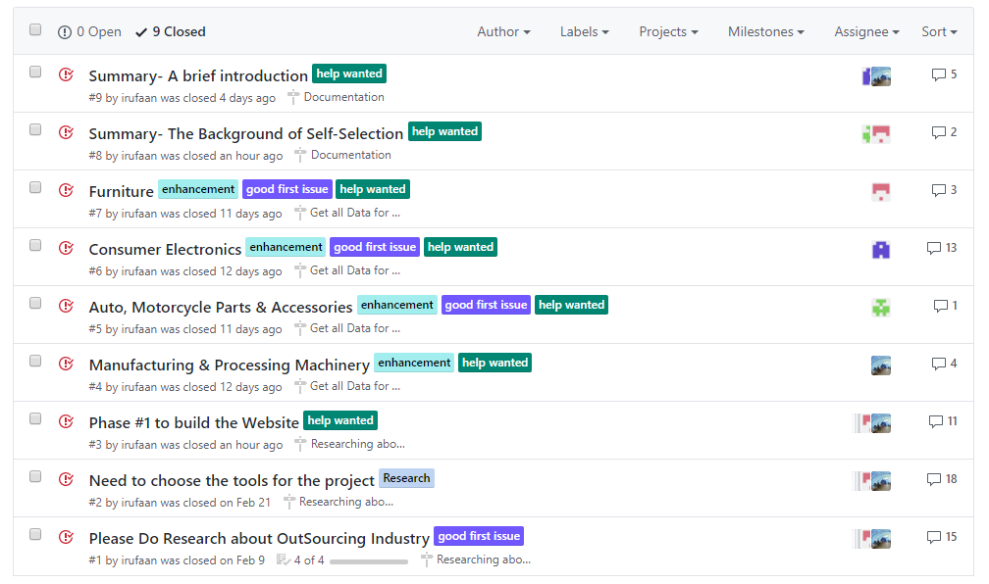

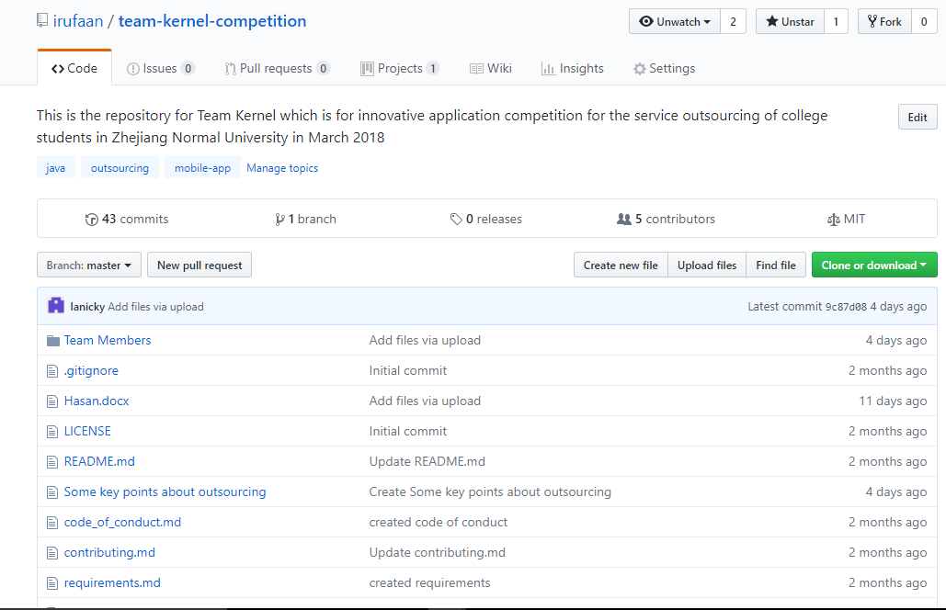

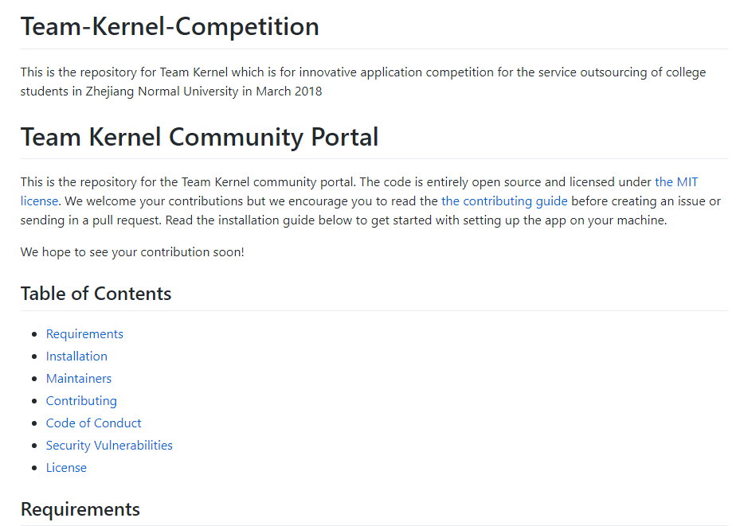

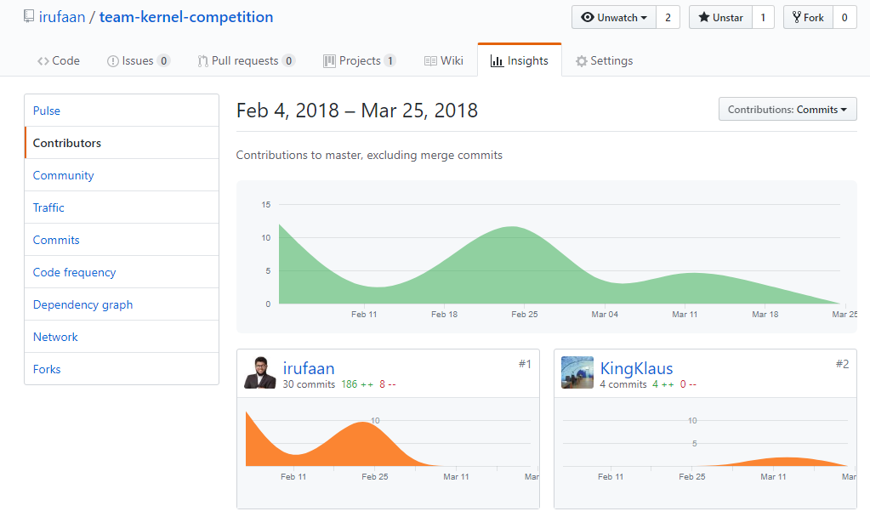

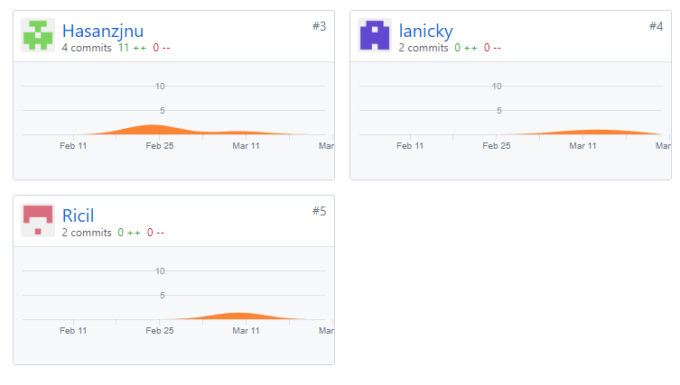

**Process Of our Task:**Whole task we did by a process. At first we chose a platform to do this task. Then we did relative researches about the outsourcing industry and other information. Following that we select tools as well as data collection, brand name selection and so on. Our whole process of the task in broadly is given below.

**Platform:** To perform the task we used GitHub. GitHub is a web-based hosting service for version control using Git. It is mostly used for computer code. It offers all of the distributed version control and source code management functionality of Git as well as adding its own features.

Advantages of using GitHub:

1. It makes it easy to contribute open source projects.

2. By using GitHub, it makes easier to get excellent documentation.

3. Showcase your work.

4. Markdown.

5. GitHub is a repository.

6 .Track changes in your code across versions.

7. Integration options.

**Research about outsourcing industry:** At first we research about outsourcing industry to get a clear view about outsourcing and how this industry operates in the market. Nowadays outsourcing industry is so much competitive like other industries. In every competitive industries research is a very important thing. Business market research is the process of collecting data to determine whether a particular product/service will satisfy the needs of our customers. With effective market research, we can gain invaluable information about our competitors, economic shifts, demographics, the current market trends and the spending traits of customers. In today’s online marketing world, owning a website is very crucial for success of any business. A website meets with multiple objective of the business owner. With a website we can not only let people know about our presence in market, but can also increase our earnings and revenue by attracting more customers. To get all these benefits and to cope up with the comprehensive online market we decide ourselves to make a website.

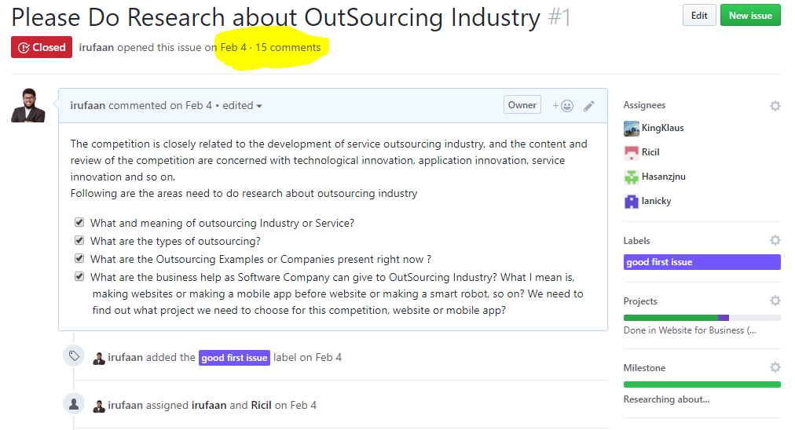

**Tools selection:** It is very important to select the accurate tools for building a software project. We research about all the tools such as server, hosting, framework, plugins that we need to build the website. After research our every team member recommend some of their opinion and then we together select the tools which is perfect for us and our work.

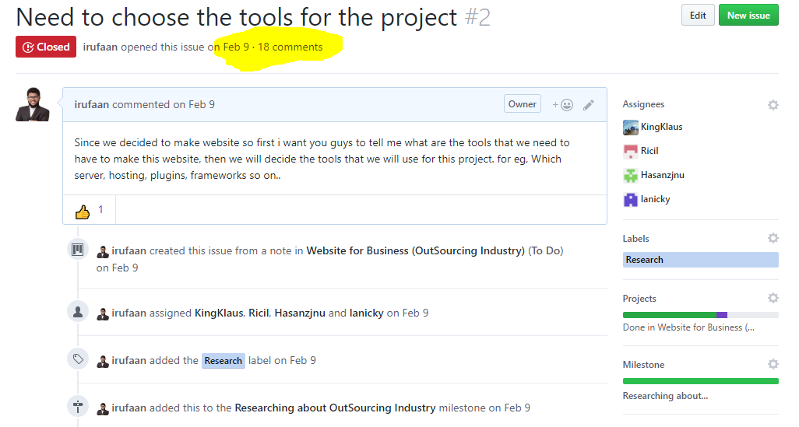

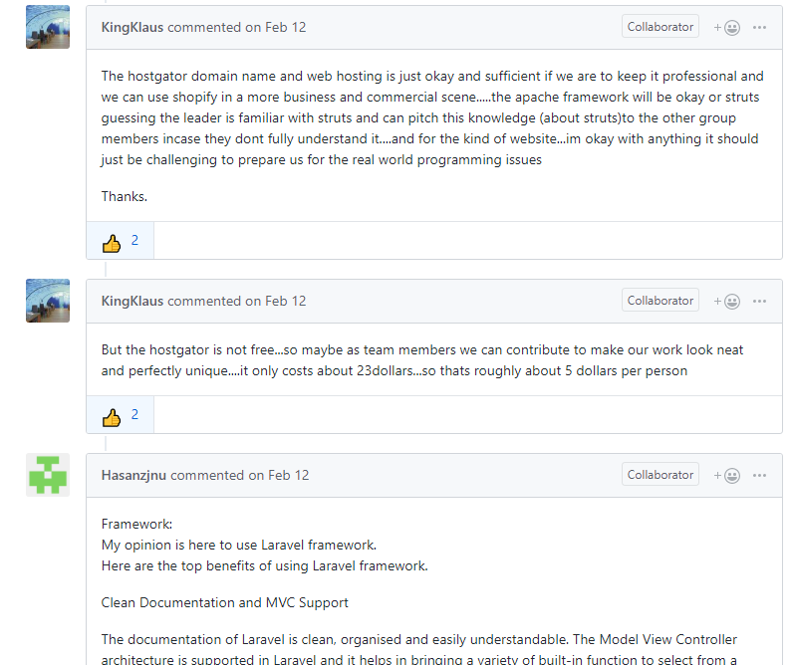

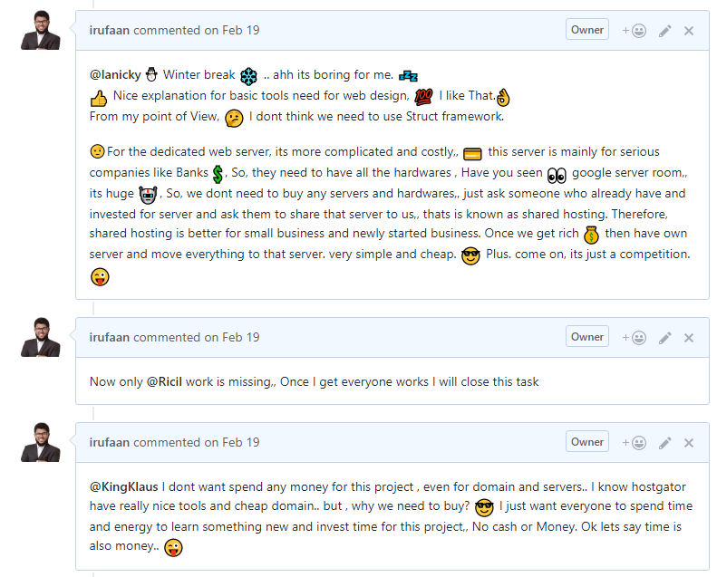

**Collection of data:**

We collect company information, product information, customer demands, customer information and all other relative information related to the market for our website. We collect data directly from those companies we are working with. We took their product information details and put in our website. For customer information we collect directly from the customers.

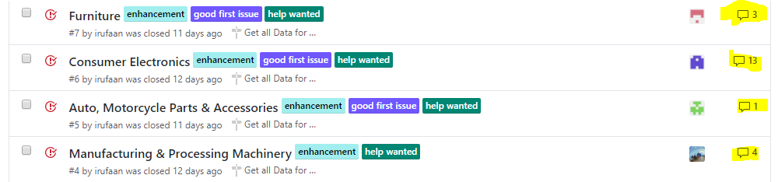

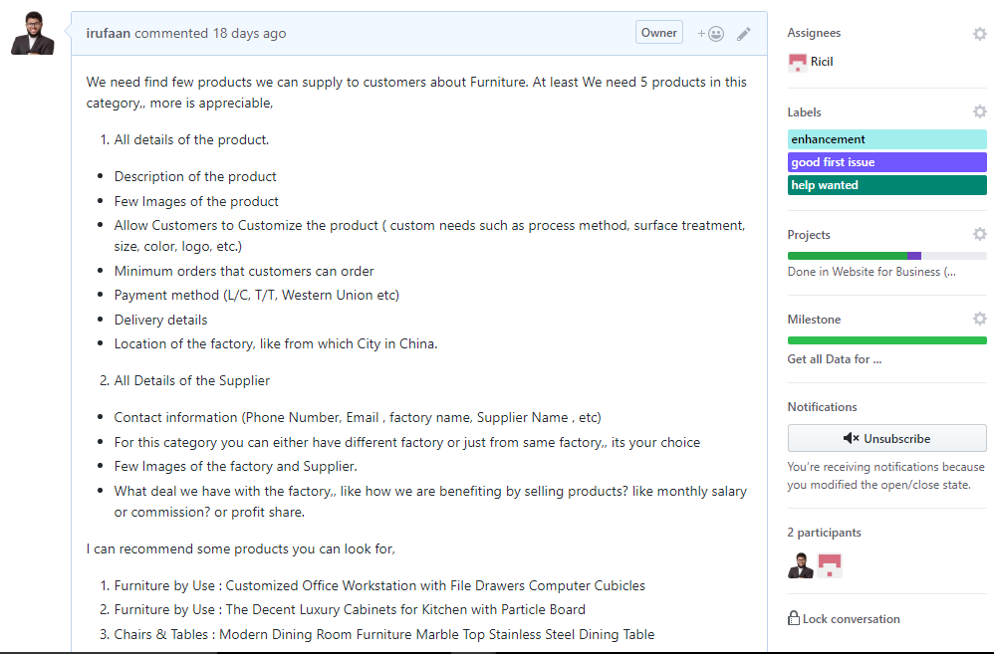

**Image and brand name selection:**

For image and brand name selection we took opinion from our team members. Every team member recommends their own choices and opinions. From those we select some unique images and brand name for our website.

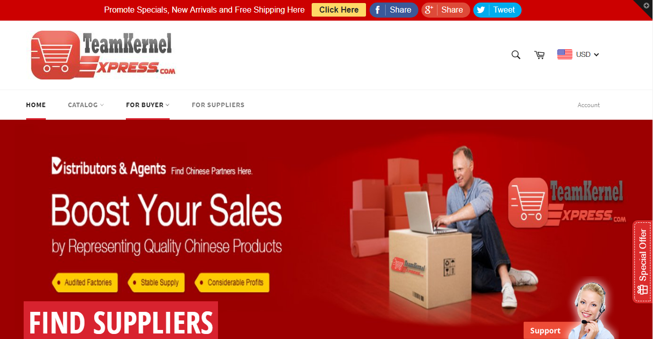

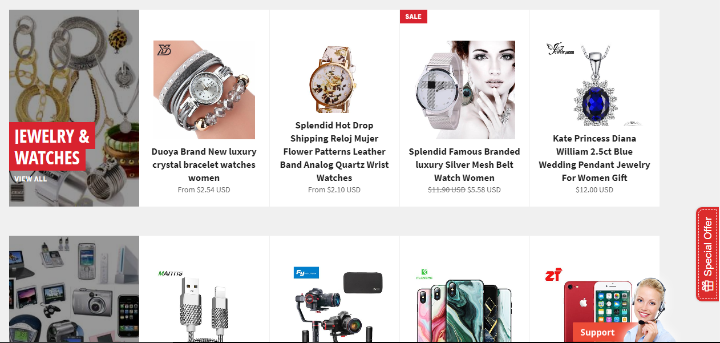

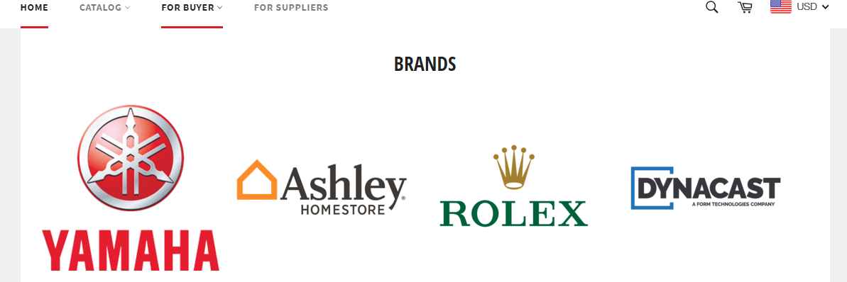

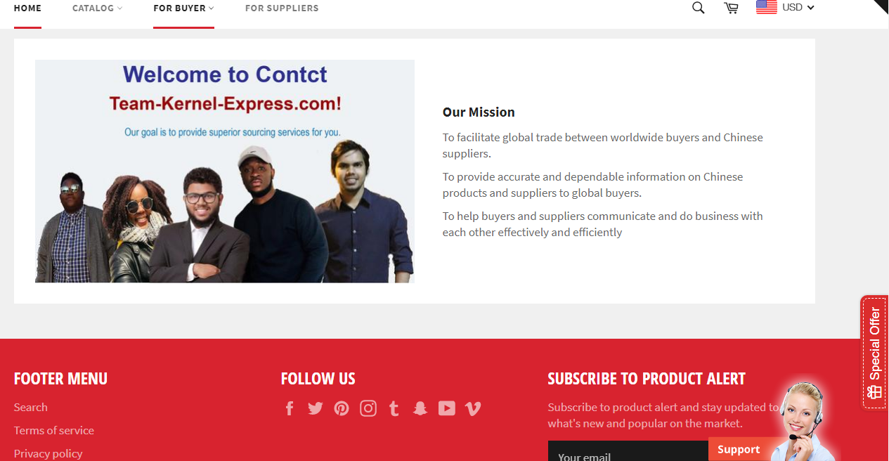

**Design and coding:**

We design the website to make it efficient and user friendly to our customers for better service. We used programming language such as Html, JavaScript, CSS, and Json for Data. We used Shopify Hosting Service as well as use some web Apps like Best Currency Converter for currency convertor and Easy Contact Form for Contacts.

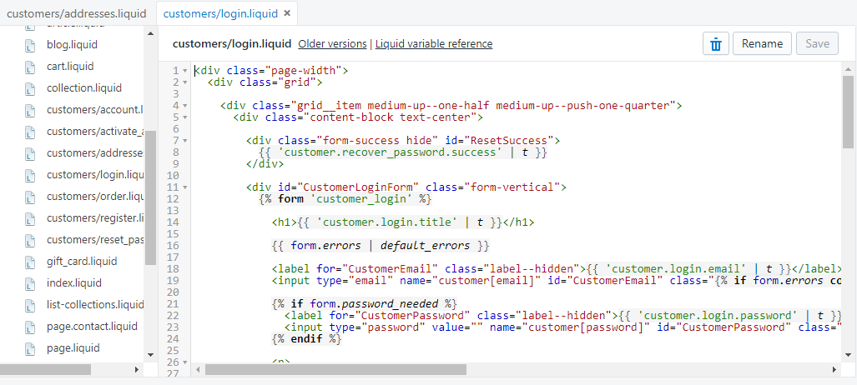

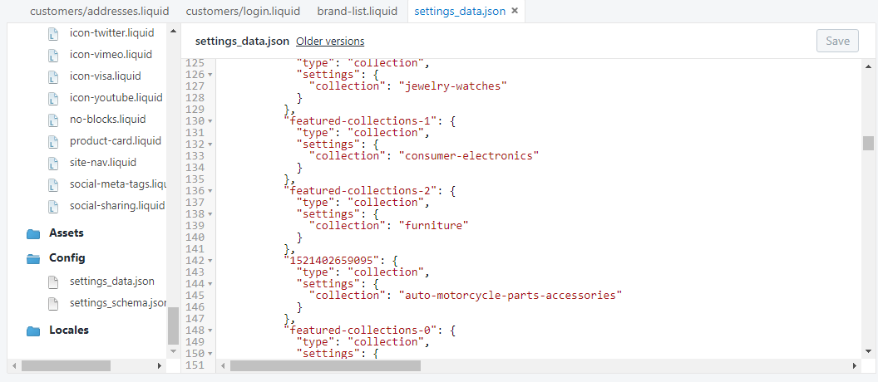

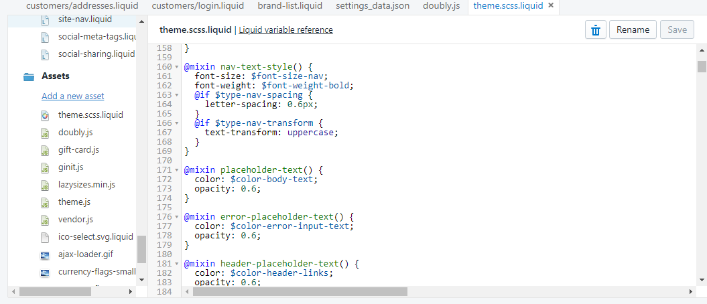

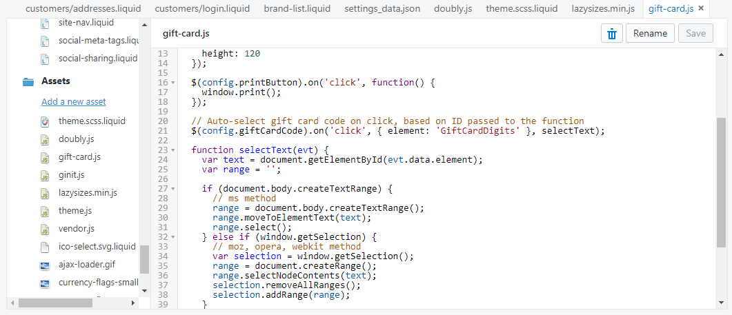

**Documentation:**

After finishing the website we start writing the documentation part such as Brief introduction, Background of self-selection and Business plan. We divided the work among our group members to make it easier.

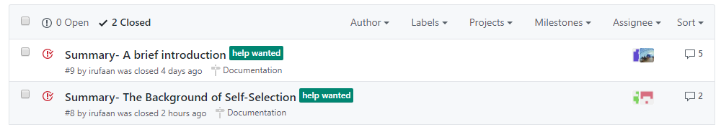

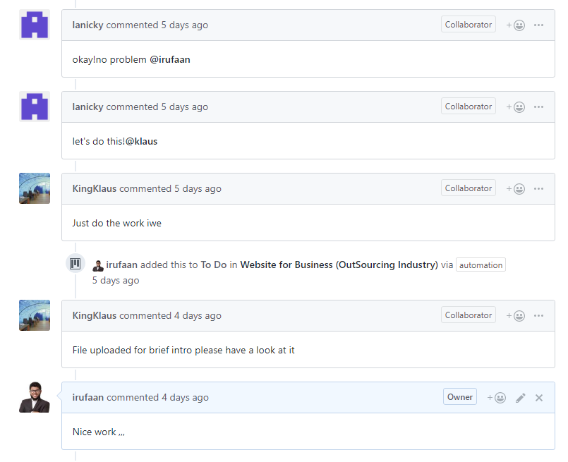

**Website overview:**

This is the website to facilitate global trade between worldwide buyers and Chinese suppliers.

To provide accurate and dependable information on Chinese products and suppliers to global buyers.

To help buyers and suppliers communicate and do business with each other effectively and efficiently.

### Services that can get to customers using this website

* Customers can get detail information about the products.

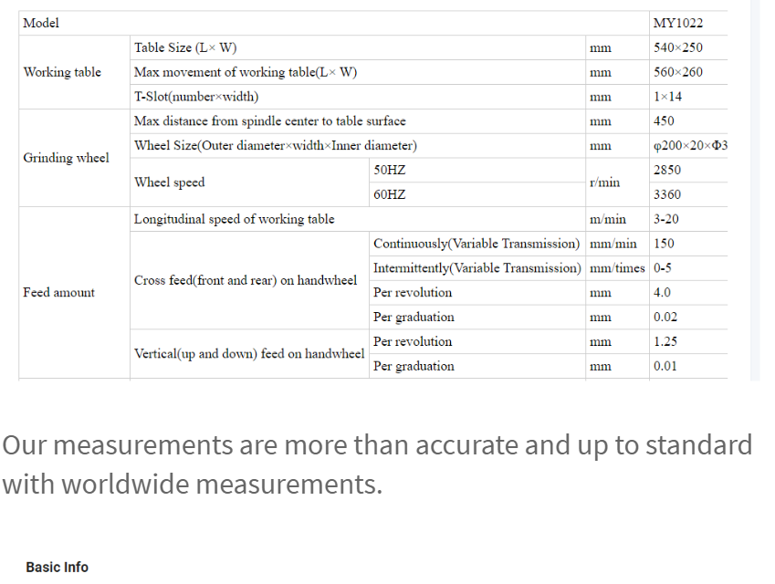

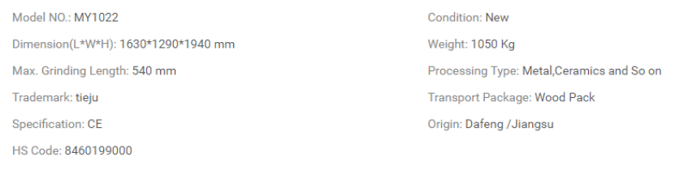

* Customers can get detail information about the company.

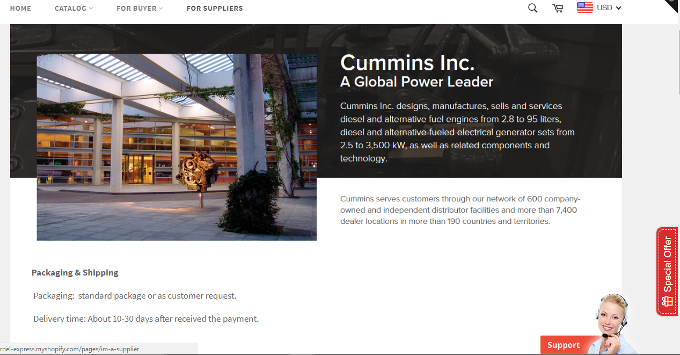

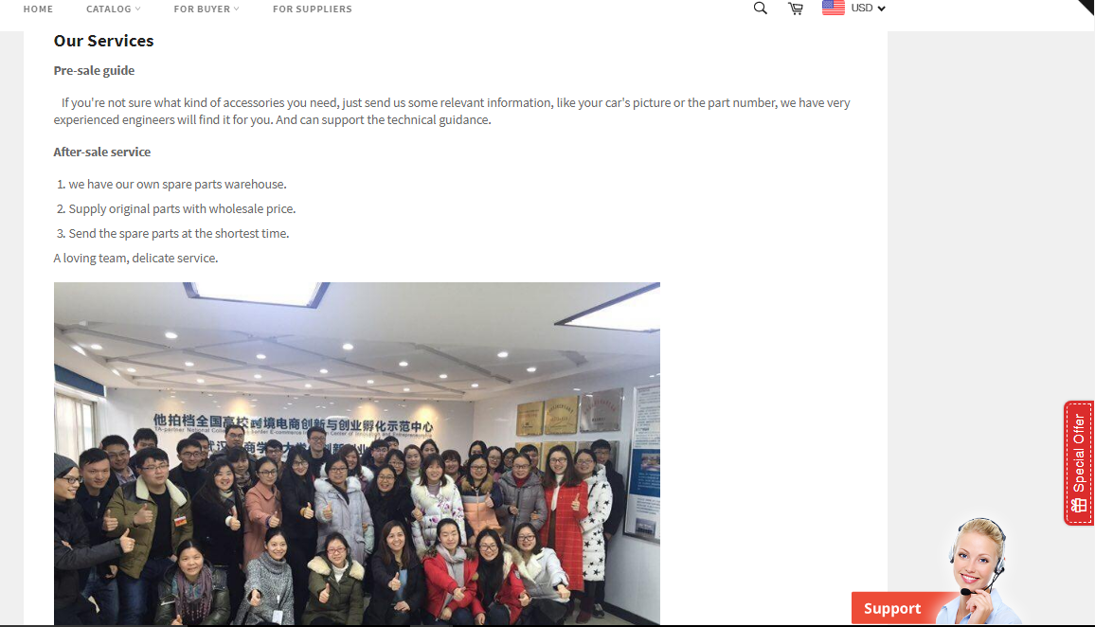

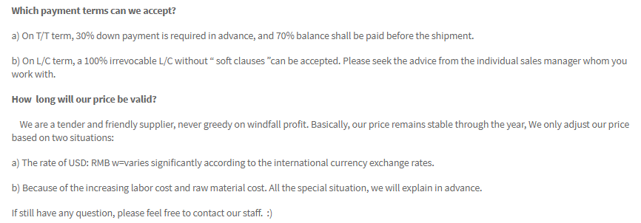

* In order to test the product before ordering in bulk quantity, Customers can buy sample product from the website

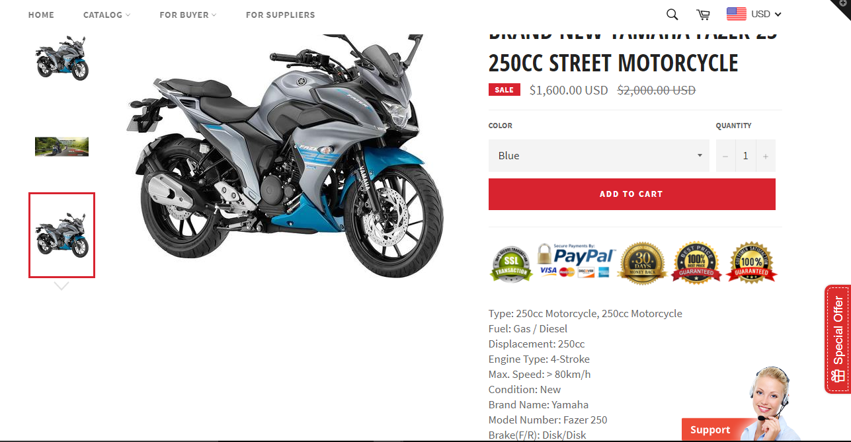

* If customer request to meet the company in China, we can arrange offline meeting

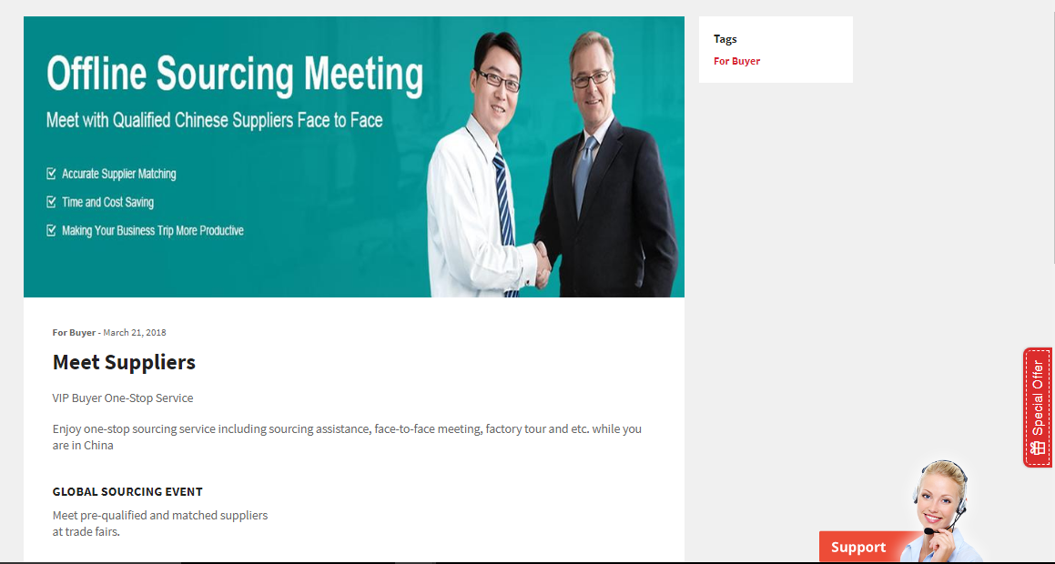

* Customers can customize the products.

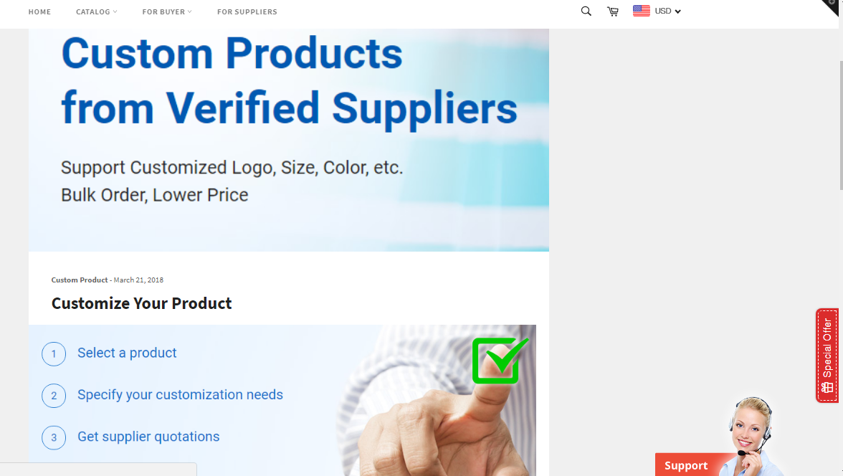

* We help customers to participate business fairs according to the seasons

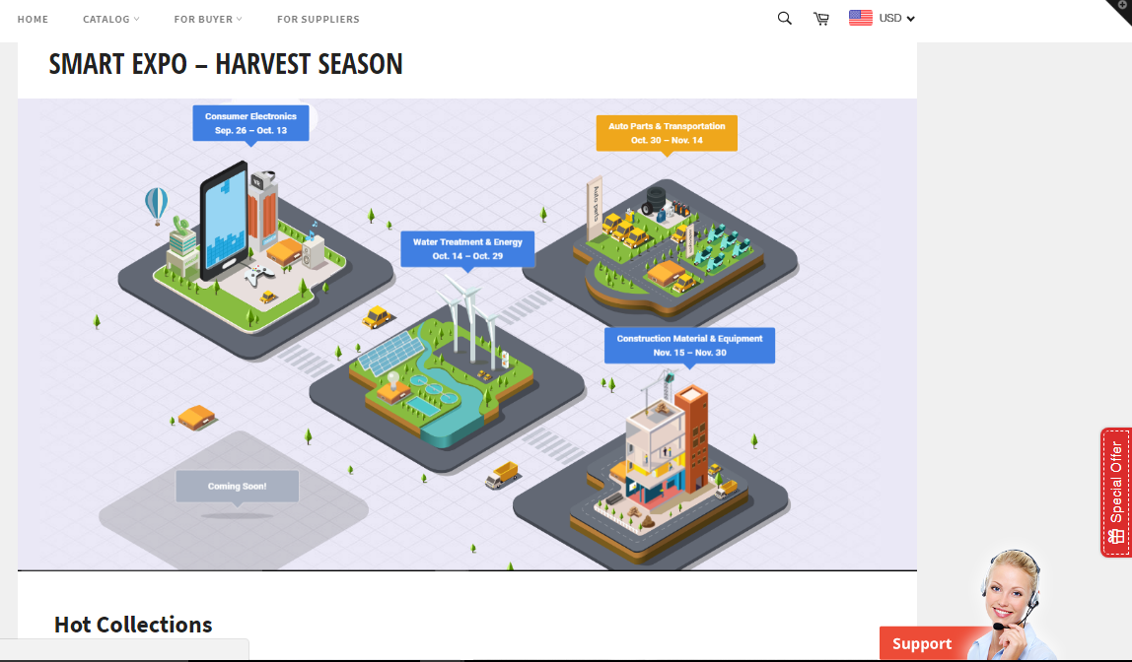

### Services that can get to Suppliers using this website

We also show suppliers the details of the available out sourcing requests. But only registered suppliers can contact to the customers. Because we don’t display customers contact details for free. First, Suppliers need to contact to us in order to access the customer contact details.

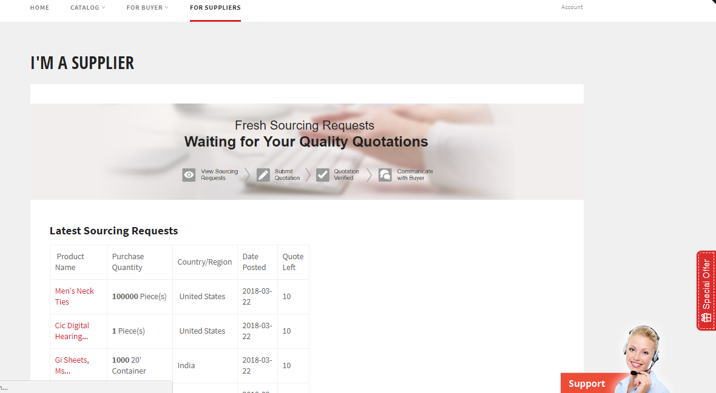

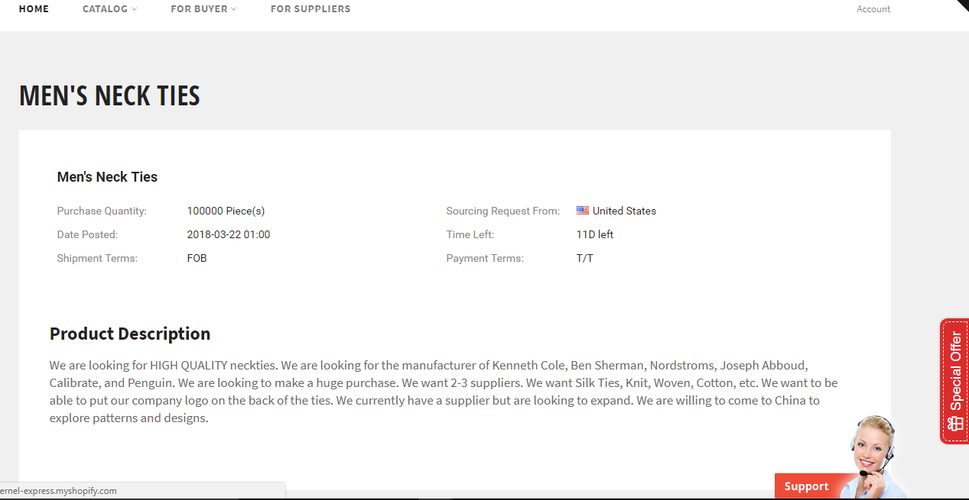

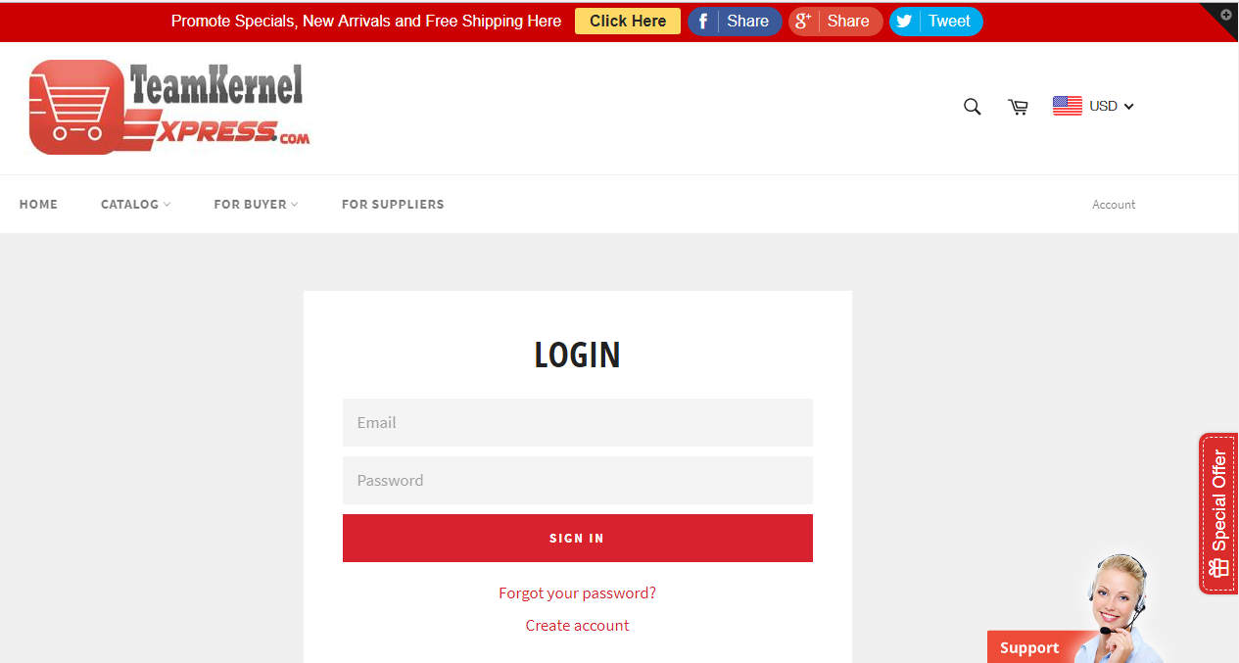

**The cost model and feasibility analysis**

So far we didn’t spend any money to make this website. But we can only publish the website after paying to domain and hosting server. We used shopify webhosting services to make this website. Our main goal for this project is to learn how to use available resources to make website instead of making everything from the scratch. We used templates, plugins, and web apps for this website.

That’s the reason we used almost one month to do research and learn about the tools that we can use to make the website. After we found the tools then to make website it took only 2 weeks.

### Conclusion

At the end by everyone’s effort we successfully finish our desired work. It helps us to improve our outsourcing knowledge, E-Commerce business knowledge. It also helps us to improve our web developing skill, team management skill and a lot more.

GitHub is the future of programming and the handling of big projects, it is fast, reliable and robust. The whole competition and its progression has been an eye opening experience into outsourcing and how it affects our day to day lives, outsourcing is definitely one for the curb and we feel is a great way to even increase a country’s revenue as well as economy as it has an impact on the economy.

### Learning outcomes

From this project we learned lots of skills and important concepts for developing out sourcing service. Following are some learning outcomes.

* We learned how to work efficiently as a team
* We learned GitHub platform to work together as a team.
* We improved our programming skills
* We improved efficient way to do research
* We learned how to manage tasks
* We learned out sourcing concepts and how to apply that knowledge in practical life.

THANK YOU.